C/C++ BINARY SEARCH OF STRUCTURED RECORDS LAB REPORT

1) Enter your name, student ID, platform (Mac or PC) and date
Name and Student ID: Jay Gupta, Student ID: 0961979
Class: CIS054 C/C++ Programming
Platform (Mac or PC): PC
Date: 5/4/2020

DESCRIPTION:
- Get a copy of structSearch program and the phony.422 data file from the class website. ✔
- Modify the program to permit the user to enter a customer name or a customer phone number
for the search. Ignore case when doing the search for the customer name. Use the stricmp function to compare the customer name entered at the keyboard with the customer name from the file. ✔
- a. search for a record near the beginning of the list, ✔
b. search for a record anywhere in the middle of the list, ✔
c. search for the record near the end of the list. ✔

DISCUSSION:
2) Complete the DISCUSSION section. It does not need to be long, but it needs to be complete.
2a) What did you do to develop the program? ("Followed the Directions" is not a complete description)

To develop the program, I looked at the slides, trying to figure out what skills we will need to use to complete this lab. When I heard it was about binary search, I was familiar with the topic from previous classes, but I needed more of a reminder. As a result, I went to YouTube and understood the topic further. This paid off, because I wasn’t confused about calculating the midpoint, which I saw you had put in such a way to avoid “overflow”. I had a few issues, which I will elaborate on in the next section, and I had asked your help. It was a nice challenge.

2b) What problems did you have and how did you overcome the problems?

The first major problem I had was with the program going in an infinite loop, when I put in a record from the beginning or the very end. I thought that was part of the lab assignment, and I got to understanding why this was happening. I took out a piece of paper and saw what is happening; it was going in an infinite loop because the midpoint was the same number after a while. I fixed it by hardcoding the if/else loop.
The second major problem I had was with the input. I had never cleared the input before, and when I was trying to make it stand trash input, it was interpreting a whole string as separate characters, which made the error message repeat itself multiple times. I eventually fixed this by cin.sync(); and a few other commands which allowed me to get the first character and make it lowercase.

2c) Compare the number of searches when looking for a data record near the beginning, the middle or near the end of the list. Which search method would give the best results when the search could be anywhere in the list?

When the search could be anywhere in the list, the binary search uses the least tests, as it continuously splits the list in half. The slower sequential list, on the other hand, goes one at a time. If, for instance, the number of lines was in the millions, this would lag the system. Binary search, however, would only take ten or fifteen more tests at the most.

PROGRAM OUTPUT:
3) Show screen shots for at least THREE searches:
a. search for a record near the beginning of the list,
b. search for a record anywhere in the middle of the list,
c. search for the record near the end of the list.
Refer to previous lab assignments for instructions on how to capture a screen or portions of a screen for either the PC or a Mac

a) Beginning: Name
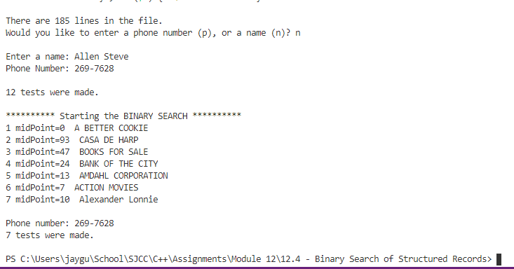

Beginning: Phone
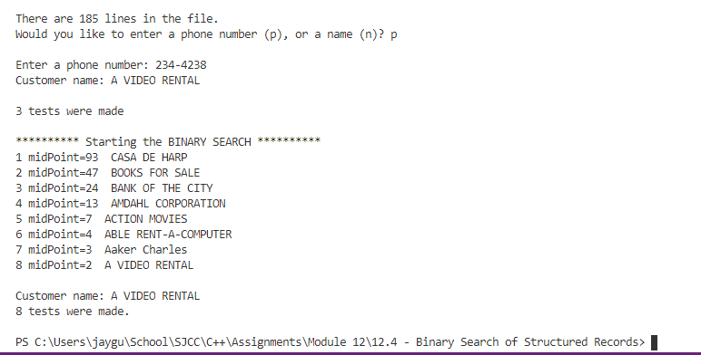

Middle: Name
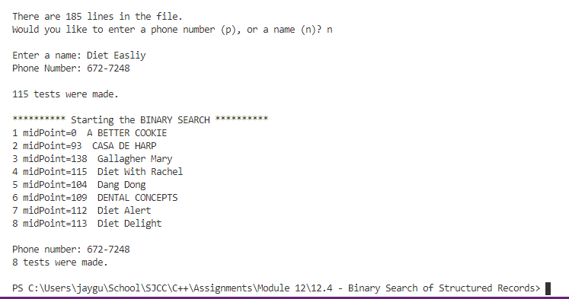

Middle: Phone
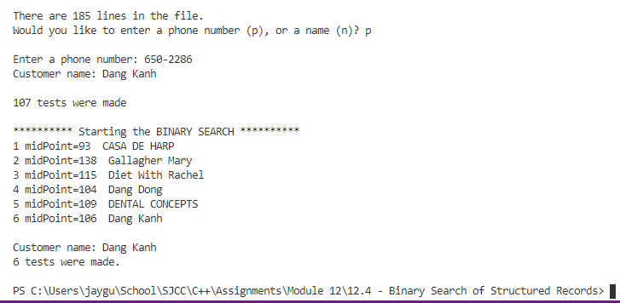

End: Name
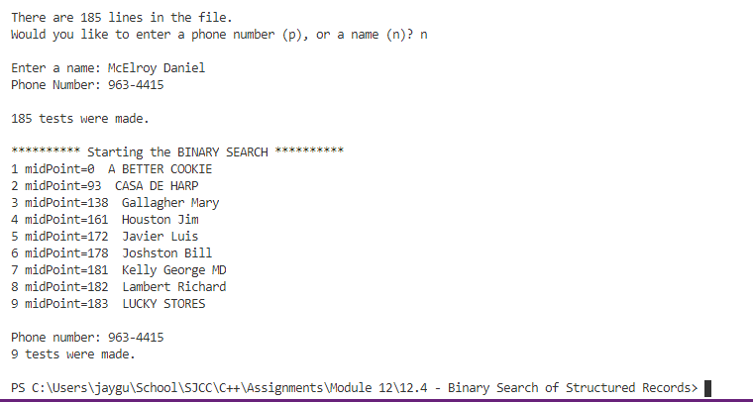

End: Phone
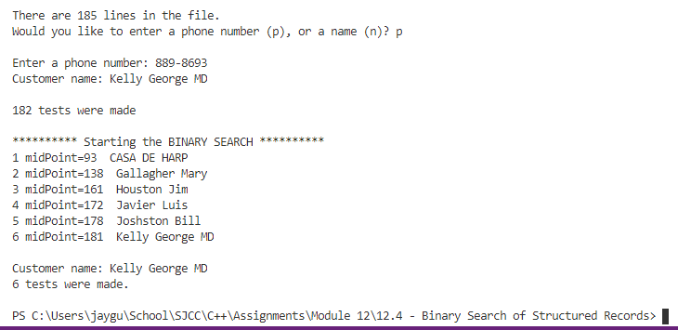
PROGRAM LISTING:
4) Copy and paste the code that YOU typed to make the program work. Your program should include a comment block at the top that shows the name of the program, date, version and your name.

/*
* Name: Jay Gupta
* Program: C++structSearchLab.cpp (V1.0)
* Date: 5/5/2020
*/

#include <iostream>
#include <fstream>
#include <cstdlib>
#include <string.h>
using namespace std;

// define the max number of records in the file
const int LIST_LENGTH = 256;

// define the lengths of each character array
const int NAME_SIZE = 40;
const int NUMBER_SIZE = 13;
const int LINE_SIZE = 80;

typedef struct S_REC {
char name[NAME_SIZE];
char number[NUMBER_SIZE];
}PhoneRec;

#define debug_messages 1

int main()
{
PhoneRec List[LIST_LENGTH]; // [length][width]
char line[LINE_SIZE]; // line of text from the disk
char filename[] = "C:\\Users\\jaygu\\School\\SJCC\\C++\\Assignments\\Module 12\\12.4 - Binary Search of Structured Records\\phony.422";
char *ptr;
int searchCounter = 0;
string phoneOrName;
int lowerBound = 1;
int midPoint = 0;
int firstOccurredMidpoint = 0;
int secondOccurredMidpoint = 0;

ifstream PhoneFile(filename);

if (! PhoneFile)
{
cerr << "Unable to open " << filename << endl;
return 1;
}

int listsize=0;
while (!PhoneFile.eof() && listsize < LIST_LENGTH)
{
line[0] = 0; // clear the line
PhoneFile.getline(line, LINE_SIZE); // read a line from the disk
if (strlen(line) > 1)
{

// pick a version of strtok and strcpy that works with your compiler

// VERSION-1
// These 5 lines work for Microsoft Visual Studio. Comment them out if using Version-2
char *nextToken = NULL; // used only by strtok_s
ptr = strtok_s(line, ".", &nextToken); // find name, separated by '.' character
strcpy_s (List[listsize].name, NAME_SIZE, ptr); // copy name to array, position listsize
ptr = strtok_s(NULL, ".\r\n", &nextToken); // find phone number
strcpy_s (List[listsize].number, NUMBER_SIZE, ptr); // copy to array, position listsize
listsize++;
}
}

int upperBound = listsize;

#if debug_messages == 1
cout << endl << "There are " << listsize << " lines in the file." << endl;
#endif

/////////// request a search string, then find it //////////
char searchString[80];
while (true) {
cout << "Would you like to enter a phone number (p), or a name (n)? ";
getline(cin, phoneOrName);

phoneOrName = tolower(phoneOrName[0]);

if (phoneOrName == "p" || phoneOrName == "n") {
break;
} else {
cout << "I don't know what you want to enter! Try again!" << endl;
continue;
}
}

cin.sync();

if (phoneOrName == "p") {

cout << endl << "Enter a phone number: ";
// cin >> searchString; // works fine for the phone number, but not the name
// This is because the names have space characters. cin >> searchString stops
// reading the input as soon as it sees a space and part of the name is lost
// Use cin.getline(searchString,80); instead to read a fill line from the keyboard.
cin.getline(searchString,80);
/////////////////////////////////////////////////////
/////////// sequential search /////////////////////// (for phone number)
/////////////////////////////////////////////////////
bool found = false;
int index;

for (index=0; index<listsize; index++)
{
searchCounter++;
if (strstr(List[index].number, searchString)) // if found
{
found = true;
break;
}
}
if (found)
{
cout << "Customer name: " << List[index].name << endl;
cout << endl << searchCounter << " tests were made" << endl;
}
else
cout << "Not found" << endl;

searchCounter = 0;

///////////////////////////////////////////////////
//////////////// binary search ////////////////////
///////////////////////////////////////////////////
searchCounter = 0;

cout << "\n********** Starting the BINARY SEARCH **********\n";
found = false;
while (found == false)
{
if (upperBound < lowerBound) // does not exist
break; // exit with found still set to false

// setting the midpoint
if (midPoint == 2) {
midPoint = 1;
} else if (midPoint == 1) {
midPoint = 0;
} else if (midPoint == (listsize - 2)) {
midPoint = (listsize - 1);
} else {
midPoint = lowerBound + (upperBound-lowerBound)/2;
}

if (midPoint == firstOccurredMidpoint || midPoint == secondOccurredMidpoint) {
// does not exist
break;
}

searchCounter++;

cout << searchCounter << " midPoint=" << midPoint
<< " " << List[midPoint].name << endl;

if (stricmp(List[midPoint].number, searchString) == 0) // if found
found = true;
else if (stricmp(List[midPoint].number, searchString) < 0) {
lowerBound = midPoint-1; // getting closer, cutoff the lower half
}
else {
upperBound = midPoint+1; // getting closer, cutoff the upper half
}
if (searchCounter % 2 == 0) {
firstOccurredMidpoint = midPoint;
} else {
secondOccurredMidpoint = midPoint;
}
}
if (found) // found
{
cout << endl << "Customer name: " << List[midPoint].name << endl;
cout << searchCounter << " tests were made." << endl << endl;
}
else
cout << "Not found in " << searchCounter << " tries." << endl << endl;
} else if (phoneOrName == "n") {
cout << endl << "Enter a name: ";
// cin >> searchString; // works fine for the phone number, but not the name
// This is because the names have space characters. cin >> searchString stops
// reading the input as soon as it sees a space and part of the name is lost
// Use cin.getline(searchString,80); instead to read a fill line from the keyboard.
cin.getline(searchString,80);

/////////////////////////////////////////////////////
/////////// sequential search /////////////////////// (for name)
/////////////////////////////////////////////////////
bool found = false;
int index;
for (index=0; index<listsize; index++)
{
searchCounter++;
if (strstr(List[index].name, searchString)) // if found
{
found = true;
break;
}
}
if (found)
{
cout << "Phone Number: " << List[index].number << endl;
cout << endl << searchCounter << " tests were made.";
}
else
cout << "Not found.";

///////////////////////////////////////////////////
//////////////// binary search ////////////////////
///////////////////////////////////////////////////

searchCounter = 0;

cout << "\n\n********** Starting the BINARY SEARCH **********\n";
found = false;
while (found == false)
{
searchCounter++;

cout << searchCounter << " midPoint=" << midPoint
<< " " << List[midPoint].name << endl;

if (upperBound < lowerBound) // does not exist
break; // exit with found still set to false

// setting the midpoint
if (midPoint == 2) {
midPoint = 1;
} else if (midPoint == 1) {
midPoint = 0;
} else if (midPoint == (listsize - 2)) {
midPoint = (listsize - 1);
} else {
midPoint = lowerBound + (upperBound-lowerBound)/2;
}

if (midPoint == firstOccurredMidpoint || midPoint == secondOccurredMidpoint) {
// does not exist
break;
}

if (stricmp(List[midPoint].name, searchString) == 0) // if found
found = true;
else if (stricmp(List[midPoint].name, searchString) < 0) {
lowerBound = midPoint-1; // getting closer, cutoff the lower half
}
else {
upperBound = midPoint+1; // getting closer, cutoff the upper half
}
if (searchCounter % 2 == 0) {
firstOccurredMidpoint = midPoint;
} else {
secondOccurredMidpoint = midPoint;
}
}
if (found) // found
{
cout << endl << "Phone number: " << List[midPoint].number << endl;
cout << searchCounter << " tests were made." << endl << endl;
}
else
cout << "Not found in " << searchCounter << " tries." << endl << endl;
}
return 0;
}

